EVOLUTION STUDY GUIDE

Explain the theory of evolution by natural selection as a mechanism for how species change over time.

Explain how fossil, biochemical, and anatomical evidence support the theory of evolution.
Paleontology (the study of prehistoric life) is a tool that scientists use to provide support for biological evolution.
- The fossil record provides valid evidence of life forms and environments along a timeline and supports evolutionary relationships by showing the similarities between current species and ancient species.
- Comparing current and ancient species shows a pattern of gradual change from the past to the present.
- Examining the fossil record of Earth reveals a history that tells a story of the types of organisms that have lived on Earth (including those that are extinct) and the relative ages of those fossils.
- The older the fossils, the less resemblance there is to modern species.

Biochemistry (the study of the chemical processes in organisms) studies genes and proteins to provide support for biological evolution.
- The more similar the DNA and amino acid sequences in proteins of two species, the more likely they are to have diverged from a common ancestor.

- Scientists study homologous structures as one form of evidence to determine the possible relationship between the evolutionary paths of two species.
  - Organisms which have diverged from a common ancestor often have homologous structures (similar characteristics resulting from common ancestry). The greater the numbers of shared structures between two species, the more closely the species are related.
- Also, the study of the anatomy of species located in different geographical locations reveals that species living in different locations under similar ecological conditions developed similar structures and behaviors.
- If a species encountered a different ecosystem due to a change in geographical location, favorable anatomical traits become established. A new species evolves with a shared common ancestor from the original population.

Summarize the hypothesized early atmosphere and experiments that suggest how the first “cells” may have evolved and how early conditions affected the type of organism that developed.

Early in the Earth’s formation, it was still cooling down and was very hot and volatile. Volcanic eruptions occurred, there was an abundance of rain and electrical storms. There was no oxygen in the atmosphere (oxygen is produced as a by-product of photosynthesis and photosynthetic organisms had not evolved at this point). The atmosphere was mostly water vapor, methane gas, ammonia, and hydrogen, which caused it to be very unstable.

Stanley Miller and Harold Urey conducted an experiment to demonstrate that conditions on early Earth were conducive to amino acids, nucleotides, and other organic compounds to form.

- When the Earth formed 4.6 billion years ago, there was no oxygen in the atmosphere.
- When unicellular prokaryotes formed, they were anaerobic (they did not use oxygen).
- Photosynthetic organisms evolved to produce the oxygen in the air and water.
- Unicellular eukaryotes evolved; some were aerobic (use oxygen).
- Multicellular organisms evolved in the water.
- Plants became terrestrial.
- Animals became terrestrial.

Principles of natural selection as proposed by Charles Darwin:
▪ Species have the potential to increase in numbers exponentially.
The ability of a population to have many offspring raises the chance that some will survive but also increases the competition for resources.

▪ Populations are genetically variable due to mutations and genetic recombination.
- Within every population, variation exists within the inherited traits of the individuals.
- Variation exists in the phenotypes (body structures and characteristics) of the individuals within every population.
- An organism’s phenotype may influence its ability to find, obtain, or utilize its resources (food, water, shelter, and oxygen) and also might affect the organism’s ability to reproduce.
- Phenotypic variation is controlled by the organism’s genotype and the environment.
  - Those individuals with phenotypes that do not interact well with the environment are more likely to either die or produce fewer offspring than those that can interact well with the environment.

▪ There is a finite supply of resources required for life.
- Living things may require space, oxygen, nutrients in the soil, a particular pH, water, sunlight, etc. They are limiting factors that can only support a maximum number of individuals.

▪ Changing environments select for specific genetic phenotypes.
▪ Those organisms with favorable adaptations survive, reproduce and pass on their alleles.
▪ The accumulation and change in favored alleles leads to changes in species over time.
- The process of adaptation leads to the increase in frequency of a particular structure, physiological process, or behavior in a population of organisms that makes the organisms better able to survive and reproduce.
  - With every generation, organisms with specific beneficial inherited traits (that arose in a previous generation due to genetic variation) become more prevalent.
  - As each generation progresses, those organisms that carry genes that hinder their ability to meet day to day needs become less and less prevalent in the population.
    - Organisms that have a harder time finding, obtaining, or utilizing, food, water, shelter, or oxygen will be less healthy and more likely to die before they reproduce or produce less viable or fewer offspring.
  - In this manner, the gene pool of a population can change over time.
- The concept of fitness is used to measure how a particular trait contributes to reproductive success in a given environment and results from adaptations.
  - Natural selection has sometimes been popularized under the term survival of the fittest.
- As the environment of a population changes, the entire process of natural selection can yield populations with new phenotypes adapted to new conditions.
- Natural selection can produce populations that have different structures, live in different niches or habitats from their ancestors. Each successive living species will have descended, with adaptations or other modifications, from previous generations.
- More individuals will have the successful traits in successive generations, as long as those traits are beneficial to the environmental conditions of the organism.
Within a species there is a variability of phenotypic traits leading to diversity among the organisms of the species. The greater the diversity, the greater the chances are for that species to survive during environmental changes.

If an environment changes, organisms that have phenotypes which are well-suited to the new environment will be able to survive and reproduce at higher rates than those with less favorable phenotypes. Therefore, the alleles associated with favorable phenotypes increase in frequency and become more common and increase the chances of survival of the species.
- Favorable traits (such as coloration or odors in plants and animals, competitive strength, courting behaviors) in male and female organisms will enhance their reproductive success. Non-random mating results in the gene pool of a population that can change over time and a species that can become increasingly adapted to its environment.
- Organisms with inherited traits that are beneficial to survival in its environment become more prevalent. For example, resistance of the organism to diseases or ability of the organism to obtain nutrients from a wide variety of foods or from new foods.
- Organisms with inherited traits that are detrimental to survival in its environment become less prevalent.

Speciation is the process of forming of a new species (or other taxonomic groups) by biological evolution from a preexisting species.
- New species usually form when organisms in the population are isolated or separated (geographic isolation) so that the new population is prevented from reproducing with the original population, and its gene pools cease to blend.
- Once isolation (reproductive or temporal, behavioral, geographic) occurs, genetic variation and natural selection increase the differences between the separated populations.
- As different traits are favored in the two populations (original and new) because of isolation, the gene pools gradually become so different that they are no longer able to reproduce. At this point the two groups are by definition different species.

Describe evolutionary selection of resistance to antibiotics and pesticides in various species.
As bacteria are exposed to antibiotics, most are killed, but a few with a resistant mutation survive. These surviving bacteria then reproduce, passing the antibiotic resistant gene to their offspring.

DDT is an insecticide previously sprayed all over the U.S. It killed most of the insects, but left a few that were resistant to it due to a mutation in a gene. Those without the gene died, but those with the mutation survived. The surviving insects reproduced and passed their insecticide resistance to their offspring.

Describe how natural selection has an impact on vaccines (know the difference between active and passive immunity).
As viruses and bacteria evolve, vaccines may no longer be effective in preventing infections from them. For example, the virus that causes influenza mutates very quickly, so new vaccines must be found.

An active immunity is when a person is infected with a pathogen or has received a vaccine and their white blood cells produce the antibodies. Memory cells with the antibodies against a specific pathogen remain in the blood for the remainder of the person’s life to make them immune to it.

A passive immunity is when antibodies are given to a person, but they did not make them themselves. These antibodies are temporary.

Analyze the classification of organisms according to their evolutionary relationships (including dichotomous keys and phylogenetic trees).
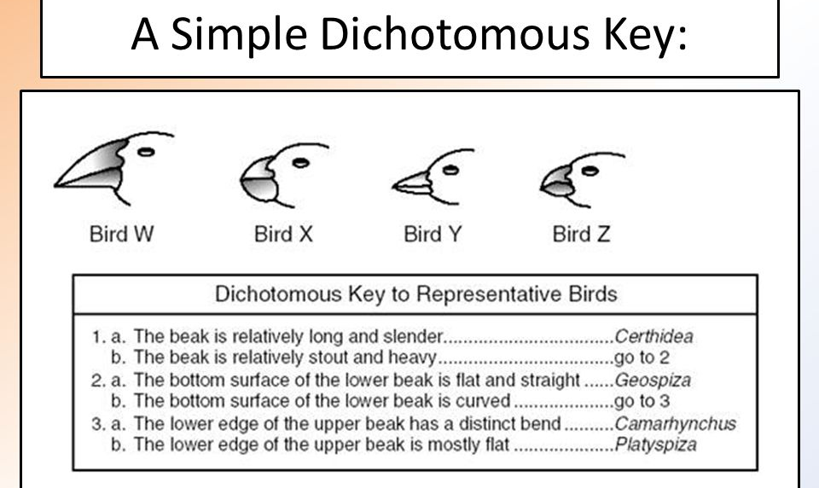
A phylogenetic tree is a scientific diagram that biologists use to represent the phylogeny (evolutionary history of a species) of organisms. It classifies organisms into major taxa (groups) based on evolutionary relationships. Phylogenetic trees are used to classify species in the order in which they descended from a common ancestor using physical characteristics. Speciation could be thought of as a branching of a family tree then extinction is like the loss of one of the branches.
- Some phylogenetic trees only express the order of divergence of a species. They do not attempt to show relative or absolute time frames.

- Some phylogenetic trees indicate an estimated time of divergence. The tree below shows the relative time that species diverged.
  - The branch between humans and whales is almost at the top of the line, while the branch between birds and tyrannosaurs happens about midway up the line, indicating that birds and tyrannosaurs diverged much sooner than humans and whales diverged.
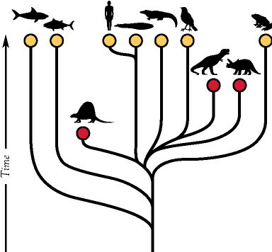

From phylogenetic trees, the following information can be determined:
- Which groups are most closely related
- Which groups are least closely related
- Which group diverged first (longest ago) in the lineage

Generalize the changing nature of classification based on new knowledge generated by research on evolutionary relationships and the history of classification system.
As new organisms are discovered or new information is discovered (often differences/similarities in DNA base sequences), the taxonomic system must be changed.

Describe the current taxonomic system.
Organisms are classified into 8 levels: domain, kingdom, phylum, class, order, family, genus, and species. The genus and species make up the organism’s scientific name (such as Homo sapiens) – this is called binomial nomenclature and was proposed by Carolus Linnaeus.

