ECOLOGY STUDY GUIDE

Analyze the interdependence of living organisms within their environments.

- Analyze the flow of energy and cycling of matter through ecosystems relating the significance of each to maintaining the health and sustainability of an ecosystem.

- Deconstruct the carbon cycle was it relates to photosynthesis, cellular respiration, decomposition, and
climate change.
- Carbon is cycled via photosynthesis and cell respiration. CO₂ is produced during cellular
respiration and released into the air/water as a by-product (waste). The CO₂ is then taken in
by photosynthetic autotrophs to be used to create glucose during photosynthesis. The
glucose is broken down during cell respiration to produce CO₂.
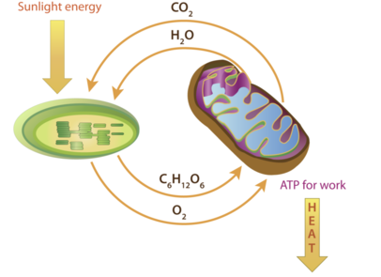
- Organisms release CO₂ when they decompose.
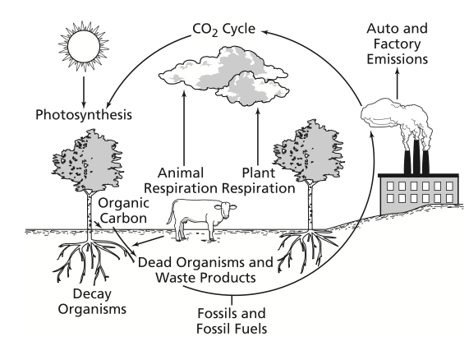
- Burning fossil fuels creates CO₂ released into the atmosphere. The Earth is warmed by the
Sun. This warmth is returned from Earth to the atmosphere in the form of heat radiation.
Many gases in the atmosphere, including CO2, absorb the Earth’s heat energy and radiate
in all directions. The energy radiated downward warms the surface and lower atmosphere.
Adding more CO2 to the atmosphere means more heat radiation is captured by the
atmosphere and radiated back to Earth.

- Summarize the nitrogen cycle (including the role of nitrogen-fixing bacteria) and its importance to synthesis of proteins and DNA.
- Plants require nitrogen, but cannot use it from the air. Nitrogen fixing bacteria from the soil and plant roots “fix” nitrogen by taking it from the air and bonding it to make usable forms for plants.
- Nitrogen is essential for making proteins and nucleic acids.
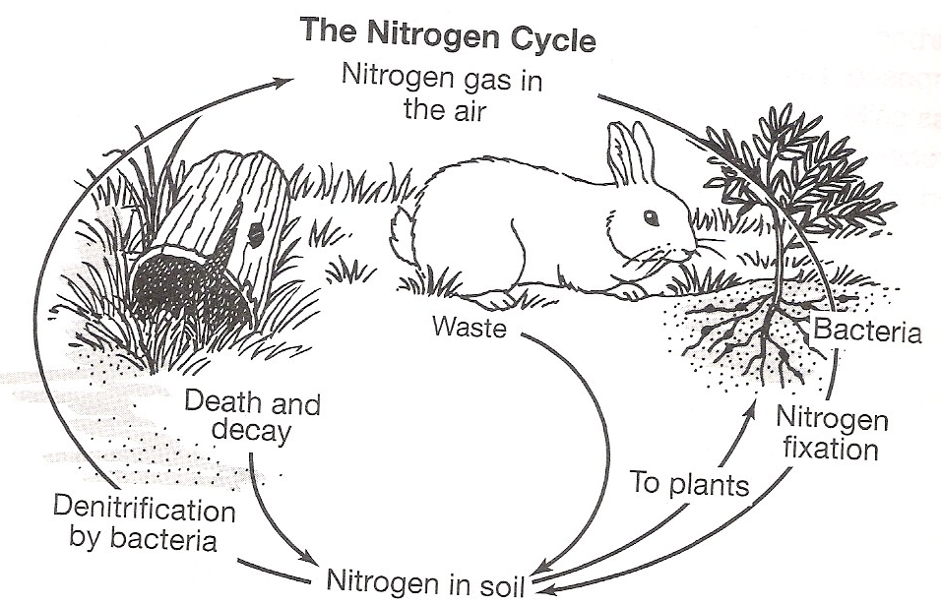

- Identify factors that influence climate such as the greenhouse effect.
- Carbon dioxide and other gasses trap heat from escaping into space. This causes heat to be trapped near the surface of the Earth. Burning fossil fuels is one cause.
- Explain the recycling of matter within ecosystems and the tendency toward a more disorganized state.
- Nitrogen, carbon, water, and other materials are recycled. Also as organisms die and decompose, their atoms and molecules are available for use by other organisms.
- Analyze energy pyramids for direction and efficiency of energy transfer.
- 10% of energy from one trophic level to the next is available. The remaining energy is given as heat or used by the organisms for its life processes.
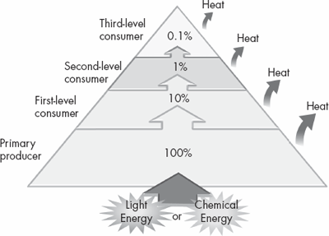

- Living systems require a continuous input of energy to maintain organization. The input of radiant energy which is converted to chemical energy allows organisms to carry out life functions.
- Within ecosystems energy flows from radiant energy of the sun through producers to consumers as chemical energy that is ultimately transformed into heat energy. Continual refueling of radiant energy is required by ecosystems.

- Analyze the survival and reproductive success of organisms in terms of behavioral, structural, and reproductive adaptations.
- Understand how survival and reproductive success is observed in species in three areas:
- behavioral adaptations
- taxis – movement of animals toward or away from a stimulus
- migration – seasonal movement of animals
- estivation – state of inactivity in animals during hot or dry seasons
- hibernation – state of inactivity in animals during cold seasons
- imprinting – young animals recognizing and bonding with an adult, usually the mother
- classical conditioning – type of learning in which two stimuli are paired, such as studying produces good grades
- trial and error learning – type of problem solving in which repeated, varied attempts are carried out until success occurs
- structural adaptations
- camouflage – blending in with surroundings usually to evade predators
- reproductive adaptations
- sexual vs. asexual reproduction – in sexual reproduction, offspring have DNA from two parents and can result in greater variety in offspring; in asexual reproduction, offspring have DNA from one parent and results in lower variety in offspring
- placental animals – mammals have a placenta that attaches, protects, and feeds the young until birth
- types of fertilization – some plants produce pollen which contains sperm for fertilization; animals can fertilize internally or externally; some organisms, such as fungi, produce spores
- Explain various ways organisms interact with each other and with their environments resulting in stability within ecosystems.
- Identify and describe symbiotic relationships
- predation – one organism kills and eats another (the prey)
- parasitism – one organism lives in or on another, feeding on it (the host)
- mutualism – two organisms live together and both benefit from the relationship
- commensalism – two organisms live together in which one benefits, but the other is neither helped nor harmed
- Exemplify various forms of communication and territorial defense
- pheromones – chemicals produced by animals and released into the environment for communication
- courtship dances – some animals exhibit movements to get the attention of the opposite sex for reproduction
- territorial defense – some animals recognize an area as belonging to them and will tag and defend them
- Explain patterns in predator/prey and competition relationships and how these patterns help maintain stability within an ecosystem.
- A graph of predator–prey density over time shows how the cycle of fluctuations results in a stable ecosystem.
- As the prey population increases, the predator population increases.
- As the predator population increases, the prey population decreases.
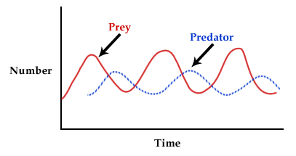

- Explain why ecosystems can be relatively stable of hundreds or thousands or years, even though populations may fluctuate.
- Though some populations have the capacity for exponential growth, there are limited resources that create specific carrying capacities and population sizes are in a dynamic equilibrium with these factors, such as food availability, climate, water, territory.
- exponential growth – increase in population size when there is adequate food, space, water, etc.
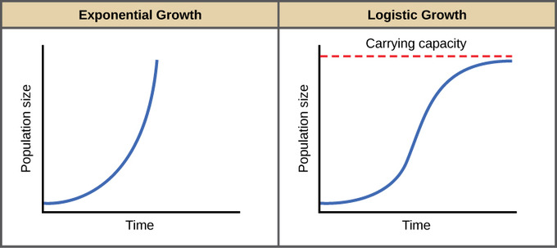
- carrying capacity – largest population size that can be supported in an environment to provide adequate resources

- Interpret various types of population graphs
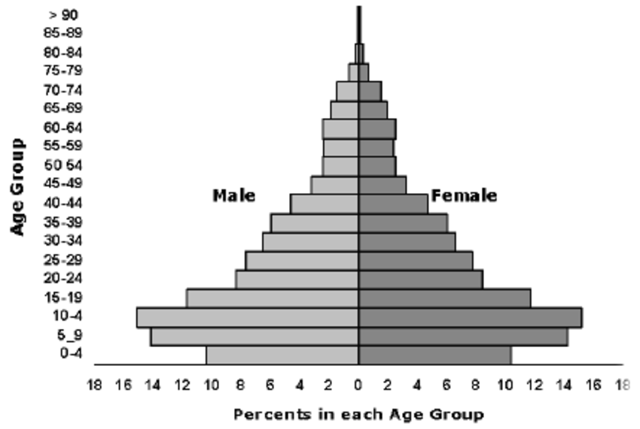

- Explain how disease can disrupt ecosystem balance.

Understand the impact of human activities on the environment (one generation affects the next).

- Infer how human activities may impact the environment.
- Summarize how humans modify ecosystems through population growth, technology, consumption of resources and production of waste.
- Interpret data regarding the historical and predicted impact on ecosystems and global climate.
- Explain factors that impact North Carolina ecosystems
- acid rain in the mountains
- beach erosion
- urban development leading to habitat destruction and water runoff
- invasive or nonnative species, such as Kudzu
- Explain how the use, protection and conservation of natural resources by humans impact the environment from one generation to the next.
- Explain the impact of humans on natural resources
- resource depletion
- deforestation
- pesticide use
- bioaccumulation – increase of chemical levels in food chains

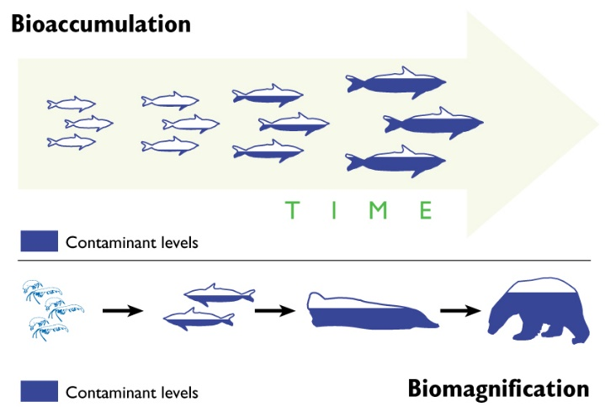

Explain how the interrelationships among organisms (including predation, competition, parasitism, mutualism, and
commensalism) generate stability within ecosystems.

An ecosystem is defined as a community (all the organisms in a given area) and the abiotic factors (such as water, soil, or climate) that affect them. A stable ecosystem is one where
- the population numbers of each organism fluctuate at a predictable rate.
- the supply of resources in the physical environment fluctuates at a predictable rate.
- energy flows through the ecosystem at a fairly constant rate over time.
These fluctuations in populations and resources ultimately result in a stable ecosystem.

Organisms in an ecosystem constantly interact. The interactions among the organisms generate stability within ecosystems.

Predation
Predation is an interaction between species in which one species (the predator) eats the other (the prey). This interaction helps regulate the population within an ecosystem thereby causing it to become stable. Fluctuations in predator–prey populations are predictable. At some point the prey population grows so numerous that they are easy to find.
- A graph of predator–prey density over time shows how the cycle of fluctuations results in a stable ecosystem.
  - As the prey population increases, the predator population increases.
  - As the predator population increases, the prey population decreases.
Competition
Competition is a relationship that occurs when two or more organisms need the same resource at the same time.
- Competition can be among the members of the same or different species and usually occurs with organisms that share the same niche.
  - An ecological niche refers to the role of an organism in its environment including type of food it eats, how it obtains its food and how it interacts with other organisms.
  - Two species with identical ecological niches cannot coexist in the same habitat.
- Competition usually results in a decrease in the population of a species less adapted to compete for a particular resource.

Symbiotic Relationships
A symbiotic relationship exists between organisms of two different species that live together in direct contact. The balance of the ecosystem is adapted to the symbiotic relationship. If the population of one or other of the symbiotic organisms becomes unbalanced, the populations of both organisms will fluctuate in an uncharacteristic manner. Symbiotic relationships include parasitism, mutualism, and commensalism.

Parasitism is a symbiotic relationship in which one organism (the parasite) benefits at the expense of the other organism (the host). In general, the parasite does not kill the host.
- Some parasites live within the host, such as tape worms, heartworms, or bacteria.
- Some parasites feed on the external surface of a host, such as aphids, fleas, or mistletoe.
- The parasite-host populations that have survived have been those where neither has a devastating effect on the other.
- Parasitism that results in the rapid death of the host is devastating to both the parasite and the host populations. It is important that the host survive and thrive long enough for the parasite to reproduce and spread.

Mutualism is a symbiotic relationship in which both organisms benefit. Because the two organisms work closely together, they help each other survive. For example,
- bacteria, which have the ability to digest wood, live within the digestive tracts of termites;
- plant roots provide food for fungi that break down nutrients the plant needs.

2

Commensalism is a symbiotic relationship in which one organism benefits and the organism is not affected. For example,
- barnacles that attach to whales are dispersed to different environments where they can obtain food and reproduce;
- burdock seeds that attach to organisms and are carried to locations where they can germinate.

Explain how populations are affected by limiting factors (including density-dependent, density-independent, abiotic, and biotic factors).

A population is a group of organisms belonging to the same species that live in a particular area. Populations can be described based on their size, density, or distribution. Population density measures the number of individual organisms living in a defined space. Regulation of a population is affected by limiting factors that include density-dependent, density-independent, abiotic and biotic factors.

Density-dependent
Limiting factors that are density-dependent are those that operate more strongly on large populations than on small ones. Density-dependent limiting factors include competition, predation, parasitism, and disease. These limiting factors are triggered by increases in population density (crowding).

Density-independent
Limiting factors that are density-independent are those that occur regardless of how large the population is and reduce the size of all populations in the area in which they occur by the same proportion. Density-independent factors are mostly abiotic (such as weather changes), human activities (such as pollution), and natural disasters (such as fires).

Abiotic and biotic factors
Limiting factors can change within an ecosystem and may affect a population.
- Abiotic factors may be chemical or physical. Some examples are water, nitrogen, oxygen, salinity, pH, soil nutrients and composition, temperature, amount of sunlight, and precipitation.
- Biotic factors include all of the living components of an ecosystem. Some examples are bacteria, fungi, plants, and animals.
A change in an abiotic or biotic factor may decrease the size of a population if it cannot acclimate or adapt to or migrate from the change. A change may increase the size of a population if that change enhances its ability to survive, flourish or reproduce.

Illustrate the processes of succession in ecosystems.

Ecological succession is the series of changes in an ecosystem when one community is replaced by another community as a result of changes in abiotic and biotic factors. There are two types of succession, primary and secondary.

Primary succession occurs in an area that has not previously been inhabited: for example, bare rock surfaces from recent volcanic lava flows, rock faces that have been scraped clean by glaciers, or a city street.
- The beginning of primary succession depends on the presence of unique organisms that can grow without soil and also facilitate the process of soil formation.
  - Lichens (mutualistic relationships between fungi and algae) and some mosses, which break down rock into smaller pieces, are among the most important pioneer species (the first organisms) in the process of primary succession. At this stage of succession there are the fewest habitats for organisms in the ecosystem.
  - Once there is enough soil and nutrients, small plants, such as small flowers, ferns, and shrubs, grow. These plants break down the rock further, and provide more soil.
  - Then seeds of other plants and small trees are able to germinate and grow.
  - Over time more species grow and die. Their decomposed bodies add nutrients to the soil and larger plant species are able to populate the area.
- As the species of plants change, the species of animals that are able to inhabit the area also change. The organisms in each stage may alter the ecosystem in ways that hinder their own survival but make it more favorable for future organisms. In this way, one community replaces another over time.
- Eventually a mature community (climax community) results where there is little change in the composition of species and perpetuates itself as long as no disturbances occur.
  - The climax community of a particular area is determined by the limiting factors of the area.
- As scientists have studied changes in ecosystems, they have found that the processes of succession are always changing ecosystems.

3

Secondary succession begins in an area where there was a preexisting community and well-formed soil: for example, abandoned farmland, vacant lots, clear-cut forest areas, or open areas produced by forest fires.
- It is similar to primary succession in the later stages, after soil has already formed.
- Something halts the succession, such as a fire, a hurricane or human activities, and destroys the established community but the soil remains intact.
- When the disturbance is over, the ecosystem interacts to restore the original condition of the community.

Succession is a continual process.
- Some stages (and the organisms that compose the communities that characterize these stages) may last for a short period of time, while others may last for hundreds of years.
- Any disturbance to the ecosystem will affect the rate of succession in a particular area. Usually secondary succession occurs faster than primary succession because soil is already present.
  - When disturbances are frequent or intense, the area will be mostly characterized by the species that are present in the early stages of succession.
  - When disturbances are moderate, the area will be composed of habitats in different stages of succession.
- The process of succession occurs in all ecosystems (i.e., forest succession, pond succession, coral reef or marine succession and desert succession).

Exemplify the role of organisms in the geochemical cycles (including the cycles of carbon, nitrogen, and water).

The role of organisms in the geochemical cycles (the movement of a particular form of matter through the living and nonliving parts of an ecosystem) since Earth is a closed system and must continually cycle its essential matter. Matter changes form but is neither created nor destroyed; it is used over and over again in a continuous cycle. Organisms are an important part of this cycling system. Matter placed into biological systems is always transferred and transformed. Matter, including carbon, nitrogen, and water, gets cycled in and out of ecosystems.

Carbon Cycle
- Carbon is one of the major components of the biochemical compounds of living organisms (proteins, carbohydrates, lipids, nucleic acids).
- Carbon is found in the atmosphere and also in many minerals and rocks, fossil fuels (natural gas, petroleum, and coal) and in the organic materials that compose soil and aquatic sediments.
- Organisms play a major role in recycling carbon from one form to another in the following processes:
  - Photosynthesis: Photosynthetic organisms take in carbon dioxide from the atmosphere and convert it to simple sugars.
  - Respiration: Organisms break down glucose and carbon is released into the atmosphere as carbon dioxide.
  - Decomposition: When organisms die, decomposers break down carbon compounds which both enrich the soil or aquatic sediments and are eventually released into the atmosphere as carbon dioxide.
  - Conversion of biochemical compounds: Organisms store carbon as carbohydrates, proteins, lipids, and nucleic acids in their bodies. For example, when animals eat plants and animals, some of the compounds are used for energy; others are converted to compounds that are suited for the predator’s body, other compounds, (such as methane and other gases) are released to the atmosphere.
- Other methods of releasing stored carbon may be:
  - Combustion: When wood or fossil fuels (which were formed from once living organisms) are burned, carbon dioxide is released into the atmosphere.
  - Weathering of carbonate rocks: Bones and shells fall to the bottom of oceans or lakes and are incorporated into sedimentary rocks such as calcium carbonate. When sedimentary rocks weather and decompose, carbon is released into the ocean and eventually into the atmosphere.

Nitrogen Cycle
- Nitrogen is the critical component of amino acids which are needed to build proteins in organisms.
- Nitrogen is found in the atmosphere as elemental nitrogen (N₂), in living organisms (in the form of proteins and nucleic acids), or in organic materials that compose soil and aquatic sediments.
- Organisms play a major role in recycling nitrogen from one form to another in the following processes:
  - Nitrogen-fixation: Nitrogen-fixing bacteria, which are found in the soil, root nodules of plants, or aquatic ecosystems, are capable of converting elemental nitrogen found in the air or dissolved in water into the forms that are available for use by plants (nitrogen fixation).
  - Intake of nitrogen into the organisms: Plants take in the nitrogen through their root systems in the form of ammonia or nitrate and in this way, nitrogen can enter the food chain.

4
  - Decomposition: When an organism dies or from animal waste products, decomposers return nitrogen to the soil.
  - Denitrification: Denitrifying bacteria break down the nitrogen compounds in the soil and release elemental nitrogen, N₂, into the atmosphere.

Water Cycle (Hydrologic cycle)
- Water is a necessary substance for the life processes of all living organisms.
- Water is found in the atmosphere, on the surface of Earth and underground, and in living organisms.
- The water cycle, also called the hydrologic cycle, is driven by the Sun’s heat energy, which causes water to evaporate from water reservoirs (the ocean, lakes, ponds, rivers) on Earth and also from organisms.
- Organisms play a role in recycling water from one form to another in water cycle. For example,
  - Intake of water into the organisms: Organisms take in water and use it to perform life functions (such as photosynthesis or transport of nutrients).
  - Transpiration: Plants release water back into the atmosphere through the process of transpiration (the evaporative loss of water from plants).
  - Respiration: All organisms metabolize food for energy and produce water as a by-product of respiration.
  - Elimination: Most organisms need water to assist with the elimination of waste products.

Explain how ecosystems maintain themselves through naturally occurring processes (including maintaining the quality of the atmosphere, generating soils, controlling the hydrologic cycle, disposing of wastes, and recycling nutrients).

There are naturally occurring Earth processes that help ecosystems maintain the materials necessary for the organisms in the ecosystem. The portion of Earth that is inhabited by life (the biosphere) is interconnected with other Earth systems: the atmosphere, the hydrosphere, and the geosphere. All of these systems must interact efficiently in order for an ecosystem to maintain itself.

Maintaining the Quality of the Atmosphere
The composition of Earth’s atmosphere is mostly the result of the life processes of the organisms which inhabit Earth (past and present).
- Plants and other photosynthetic organisms need to produce enough oxygen for themselves and all other organisms on Earth to maintain a balance of atmospheric carbon dioxide and oxygen.
- The oxygen that is produced through the process of photosynthesis is also responsible for the ozone layer in the atmosphere and prevents much of the Sun’s ultraviolet radiation from reaching Earth’s surface and protects the biosphere from the harmful radiation.
- The normal cycling of oxygen and carbon dioxide occurs as plants produce more oxygen through photosynthesis than they consume through respiration, while animals use this oxygen in cellular respiration and release carbon dioxide used by the plants in photosynthesis.
- Nitrogen is maintained in the atmosphere through the nitrogen cycle.
- Water is maintained in the atmosphere through the water cycle.
  - As water vapor condenses in the atmosphere, impurities (such as dust and particulates) are removed from the atmosphere and fall to Earth with precipitation. In this manner, the air is cleaned after a rain or snow fall.

The greenhouse effect is the normal warming effect when gases trap heat in the atmosphere.
- Greenhouse gases (such as carbon dioxide, oxygen, methane, and water vapor) trap heat energy and maintain Earth’s temperature range.
- Greenhouse gases do not allow heat to pass through very well. Therefore, the heat that Earth releases stays trapped under the atmosphere.
- The amount of carbon dioxide in the atmosphere cycles in response to the degree to which plants and other photosynthetic organisms cover Earth and absorb carbon dioxide.

Amount of CO₂ in the atmosphere | Greenhouse effect | Average Global Temperature | Plant cover on Earth | Rate of photosynthesis | Amount of CO₂ absorbed by plants | Amount of CO₂ in the atmosphere
higher | increases | increases | increases | increases | increases | decreases
lower | decreases | decreases | decreases | decreases | decreases | increases

- The amount of carbon dioxide in the atmosphere also cycles in response to the degree to which oceans cover Earth. The salt water of oceans acts as a sink for carbon dioxide, absorbing what plants do not use and converting it to various salts such as calcium carbonate.

5

Generating Soils
As part of the geosphere, the soils on Earth are constantly being generated and eroded.
- All soils are composed of four distinct components – inorganic minerals, organic matter, water, and air.
- As the weathering of inorganic materials from wind, water, and ice and the decaying of organic materials continue, the process of soil generation continues.
- Soil erosion and deposition are natural processes that move soil from one location to another due to water, wind, ice and other agents.
- In most areas, the presence of plants allows the process of soil production to be consistent with the process of soil erosion so that the overall amount of soil remains constant.
- The presence of soil in an ecosystem allows for succession to take place.

Controlling the Hydrologic Cycle:
The hydrologic cycle is maintained by the energy of the Sun and the effect of weather.
The hydrologic cycle purifies water in several ways:
- Evaporated water is pure water containing no impurities.
- As water seeps down through the soil and rock it is physically filtered of impurities.
- As water flow slows, heavier particles of sediment settle out, leaving purified water to travel toward the oceans.

Disposing of Waste & Recycling Nutrients
- Waste materials from organisms are decomposed by bacteria or other organisms in the soil or in aquatic ecosystems.
Nutrients are cycled through an ecosystem from organisms to the environment and back through series of specific processes known as geochemical cycles.

Explain how human activities (including population growth, technology, and consumption of resources) affect the physical and chemical cycles and processes of Earth.

Humans play a role in ecosystems and geochemical cycles. People depend on the resources and geochemical cycles of Earth to provide clean water, breathable air, and soil that is capable of supporting crops. Human activities, including population growth, technology, and consumption of resources, can affect the cycles and processes of Earth.
- The carrying capacity of an environment is defined as the maximum population size that can be supported by the available resources.
- Various factors (such as energy, water, oxygen, nutrients) determine the carrying capacity of Earth for the human population.

In order to meet the needs of humans to survive indefinitely (sustainability), there needs to be a balance between Earth’s resources and carrying capacity, the needs of humans, and the needs of other species on Earth. Factors that affect the sustainability of humans include:

Population Growth
- Population growth world-wide has grown exponentially. Based on current trends, scientists predict that the population will continue to grow at a rapid rate.
- The natural slowing of population growth as it nears Earth’s carrying capacity is due to an increase in the death rate and a decrease in the birth rate as a result of:
  - Food and water shortages
  - Pollution of the environment
  - Spread of diseases
- An increasing population can have an effect on the amount of available clean water.
  - If clean water is being depleted at a greater rate than it can be purified, it is not considered renewable in our lifetime.
- An increasing population can have an effect on the amount of waste that is produced.
  - Although there are mechanisms in place to control the disposal of some waste products, more waste is produced than can be managed effectively.
  - Some waste products require complicated and costly means for removal once they are introduced into the environment.
- An increasing population can have an effect on the amount of available fertile soil for agriculture (food resources).
  - Soil is often lost when land is cleared, making the land unsuitable for agriculture.
  - Worldwide demand for land (for agriculture or habitation) has led to deforestation.
    - As forests are cut down, there are fewer trees to absorb atmospheric carbon dioxide. The increase in atmospheric carbon dioxide contributes to global warming by preventing heat from radiating back into space.
6
    - Deforestation can increase the rate of erosion (both wind and water) and decrease the rate of soil generation.
- Human population growth has depleted the amount of fertile soil, clean water and available land in many areas of the world. When these resources become scarce, many natural processes (such as the water cycle, the carbon cycle, the nitrogen cycle, and the physical process of soil regeneration) are affected.

Technology
Different types of technology have applied scientific knowledge in order to either find solutions to problems or develop products to help meet the needs of humans. Although technology has benefited humankind, it has also contributed to the pollution of the air, water, and land. For sustainability, humans depend on technology to now provide cleaner energy sources, safer ways to deal with waste, and better methods for cleaning up pollution. Technological advances in agriculture, industry, and energy can have a positive or negative impact on Earth.

Agricultural technology
- Advances in agricultural methodology, tools, and biotechnology have improved the ability to grow crops to sustain a growing world population.
- Sustainable agricultural practices can help conserve fertile soil and reduce soil erosion.
- Farm machinery (such as tractors and combines) consumes nonrenewable resources and can contribute to erosion and air pollution.
- The addition of substances (such as fertilizers, pesticides, fungicides, livestock waste) to the environment can alter the composition of soil and can have a positive or negative effect on the water, carbon or nitrogen cycles.

Industrial technology
- Advances in industrial technology have changed the world and have led to developments in communication, transportation, and industry.
- The development of certain chemicals, such as CFCs (chlorofluorohydrocarbons), contributes to the depletion of the ozone layer, which results in increased ultraviolet rays reaching Earth. CFCs are used in producing foam packing materials, for cleaning electrical components, and refrigeration chemicals (Freon).
- Technological advances have revolutionized the communication industry; however, the disposal of outdated or damaged equipment is becoming an increasing concern.
- The burning of fossil fuels for industry and transportation increases sustainability of the growing human population; however, it also:
  - increases the greenhouse gases released in the atmosphere (mainly carbon dioxide), which increases global temperatures (global warming) that affect sea levels, climate and atmospheric composition
  - produces acid rain (pollutants in the air combining with water to cause the normal water pH to be lowered)
  - Acid rain decreases the pH of the soil and can leach nutrients from soils or destroy plant life.
  - Acid rain changes the pH of aquatic ecosystems and therefore affects the types of organisms that can survive there.

Alternative energy technology
- Using natural renewable energy sources (such as wind, water, geothermal, or solar energy) decreases the burning of fossil fuels, which increases the quality of the atmosphere and the cycles involved.
- Using nuclear energy technology provides an alternative energy source that does not impact the atmosphere. However, the waste produced from nuclear energy use is becoming an increasing concern.

Consumption of Resources
- As the population increases and technology expands, the demand for Earth resources also increases. However, there is a limited supply of these resources available to sustain the human population.
- Some resources (such as food, clean water, and timber) are considered renewable resources, those that can be produced at roughly the same rate that they are consumed.
  - Renewable resources have factors that limit their production, for example the amount of grain that can be produced is limited by the amount of land available for farming, fertility of the land, productivity of the grain, or availability of clean water.
- Other resources, such as fossil fuels, are nonrenewable resources, those that cannot be produced at the same rate that they are consumed. For example,
  - The demand for minerals, metals, and ores increases because these strategic materials are vital to industry but are decreasing in availability.
  - Minerals are regarded as nonrenewable because mineral deposits that can be extracted economically are formed so slowly by geological processes that their formation as a means of replacing what we are using is of no practical use to us.
Sustainable use of resources can be accomplished by reducing consumption, reusing products rather than disposing of them, or recycling waste to protect the environment. RFM 9/10

